1. The lengths of the sides of a rectangular plate are measured, and the diagram shows the

measured values with their uncertainties.

(50 ± 1) mm

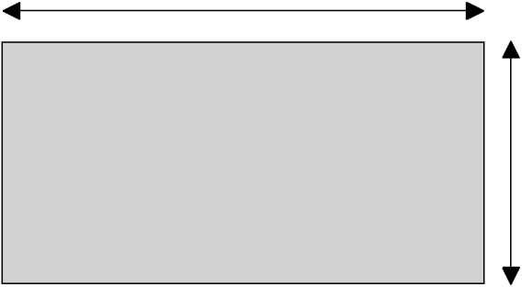

(25 ± 1) mm

Which of the following is the best estimate of the percentage uncertainty in the calculated **area** of the plate?

A. ± 2%

B. ± 4%

C. ± 6%

D. ± 8%

2. Which of the following represents two vector quantities?

* 1. distance, acceleration
  2. kinetic energy, work
  3. force, momentum
     1. electric field strength, electric potential

3. The time period *T* of oscillation of a mass *m* suspended from a vertical spring is given by

the expression

*T* 2π *m*

*k*



where *k* is a constant.

Which **one** of the following plots will give rise to a straight-line graph?

1. *T* 2against  *m*

B. $\sqrt{T}$ against $\sqrt{m}$

C. *T* against *m*

*D. $\sqrt{T}$* against *m*

4. When a voltage V of 12.2 V is applied to a DC motor, the current I in the motor is 0.20 A. Which **one** of the following is the output power *VI* of the motor given to the correct appropriate number of significant digits?

A. 2 W

B. 2.4 W

C. 2.40 W

D 2.44 W

5. The diagram below shows a boat that is about to cross a river in a direction perpendicular to the bank at a speed of 0.8ms−1 . The current flows at 0.6ms−1 in the direction shown.

Bank

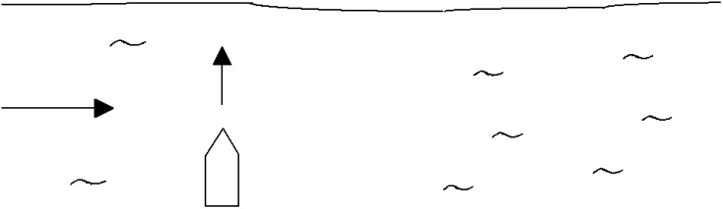

|  |  |  |
| --- | --- | --- |
| 0.6ms−1 | 0.8ms−1 |  |
|  |  |

Boat



Bank

The magnitude of the displacement of the boat 5 seconds after leaving the bank is

1. 3 m.
2. 4 m.
3. 5 m.
4. 7 m

6. The graph shows the variation with time *t* of the velocity *v* of an object

|  |  |  |
| --- | --- | --- |
|  | *v* |  |

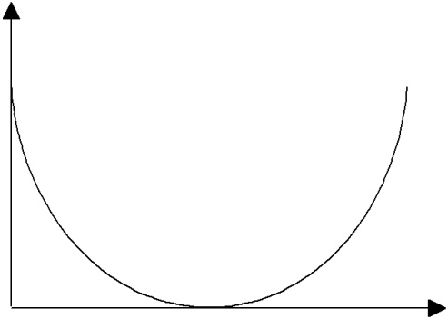

*t*

Which **one** of the following graphs best represents the variation with time *t* of the acceleration *a* of the object?

|  |  |  |  |  |  |  |
| --- | --- | --- | --- | --- | --- | --- |
| A. | *a* |  | B. | *a* |  |  |
|  |  |  |  |  |  |
|  | 0 0 | *t* |  | 0 0 | *t* |  |
|  |  |  |  |  |

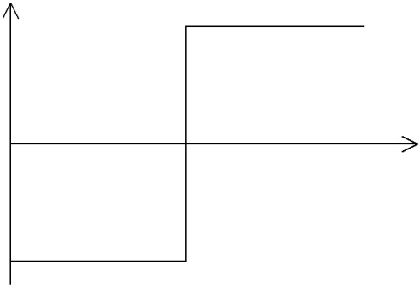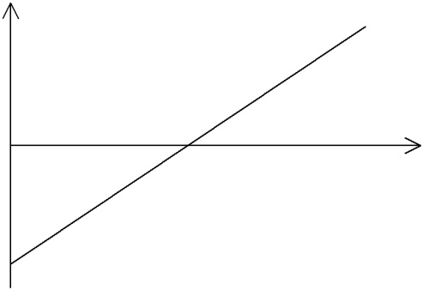

|  |  |  |  |  |  |  |
| --- | --- | --- | --- | --- | --- | --- |
| C. | *a* |  | D. | *a* |  |  |
|  | 0 0 | *t* |  | 0 0 | *t* |  |
|  |  |  |  |  |

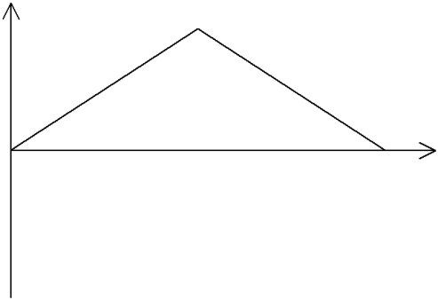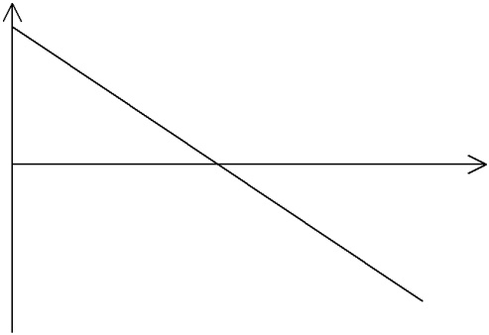

7. Four cars W, X, Y and Z are on a straight road. The graph below shows the variation with

time t of the distance s of each car from a fixed point.

* + X
    - Y

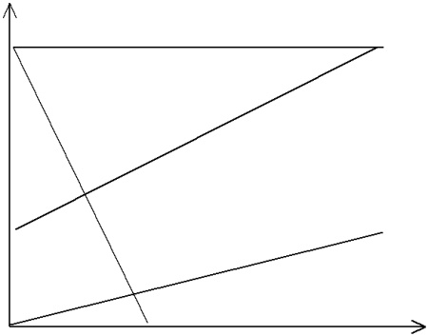

*t*

Z

Which car has the greatest speed?

A. W

B. X

C. Y

D. Z

8. The graph shows the variation with time *t* of the acceleration *a* of an object

|  |  |  |  |  |  |  |  |  |  |  |
| --- | --- | --- | --- | --- | --- | --- | --- | --- | --- | --- |
| 20 |  |  |  |  |  |  |  |  |  |  |
| 15 |  |  |  |  |  |  |  |  |  |  |
| 10 |  |  |  |  |  |  |  |  |  |  |
| *a* / m s–2 |  |  |  |  |  |  |  |  |  |  |
| 5 |  |  |  |  |  |  |  |  |  |  |
| 0 |  |  |  |  |  |  |  |  |  |  |
| 0 | 1 | 2 | 3 | 4 | 5 | 6 | 7 | 8 | 9 | 10 |
|  |  |  |  |  | *t*/s |  |  |  |  |  |

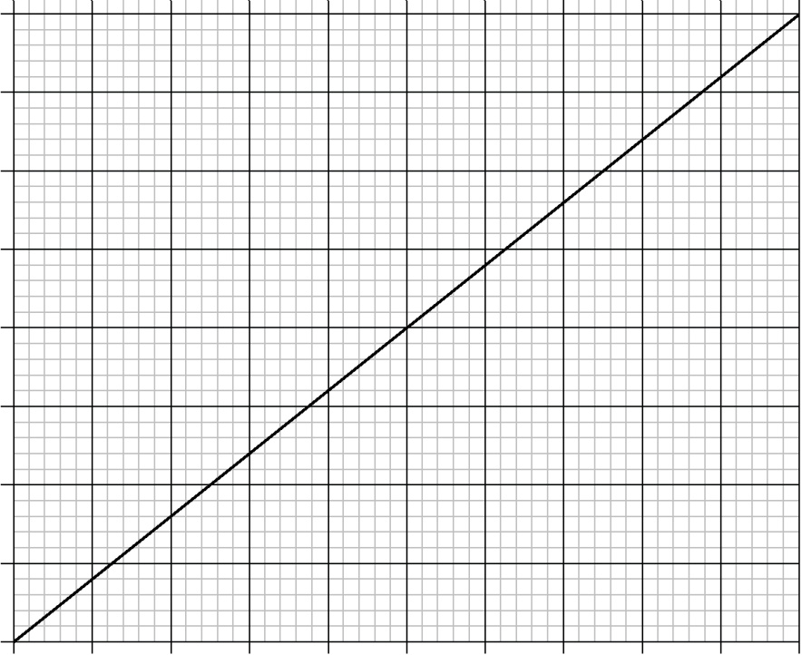

The object is at rest at time *t* = 0.

Which of the following is the velocity of the object at time *t* = 6.0 s?

1. 0.50 m s–1.
2. 2.0 m s–1.
3. 36 m s–1.
4. 72 m s–1.

9. A block of mass *m* is pulled along a horizontal, frictionless surface by a force of

magnitude *F*. The force makes an angle θ with the vertical

|  |  |  |  |  |  |  |
| --- | --- | --- | --- | --- | --- | --- |
|  |  |  | | *F* | |  |
|  |  |  |  | θ | |  |
|  |  | block |  |  |  |  |
|  |  |  |  |  |  |

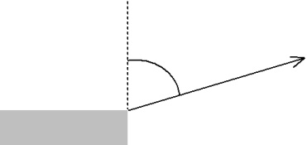

The magnitude of the acceleration of the block in the horizontal direction produced by the force *F* is

A.

B.

C.

D.

10. Two spheres of masses *m1* and *m*2 are moving towards each other along the same

straight-line with speeds *v*1 and *v*2 as shown.

|  |  |  |  |  |  |  |  |
| --- | --- | --- | --- | --- | --- | --- | --- |
|  |  |  |  |  | positive direction | |  |
| *m*1 |  | *v*1 | *v*2 |  | *m*2 | |  |
|  |  |  |
|  |  |  |  |  |  |  |  |

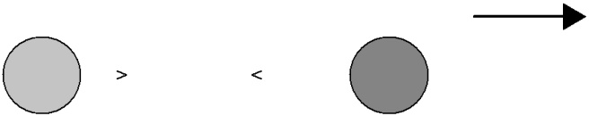

The spheres collide. Which of the following gives the total change in linear momentum of the spheres as a result of the collision?

1. 0
2. *m*1*v*1 *m*2*v*2
3. *m*1*v*1− *m*2*v*2
4. *m*2*v*2− *m*1*v*1

11. A constant force of magnitude *F* acts on a body. The graph shows the variation with time

*t* of the momentum *p* of the body.

|  |  |  |  |
| --- | --- | --- | --- |
|  | 200 |  | |
|  | 180 |  | |
|  | 160 |  | |
|  | 140 |  | |
|  | 120 |  | |
| *p*/kg m s–1 | 100 |  | |
|  |  | |
|  | 80 |  | |
|  | 60 |  | |
|  | 40 |  | |
|  | 20 |  | |
|  | 0 |  | |
| 0 | 1 | 2 | 3 | 4 | 5 | 6 | 7 | 8 | 9 | 10 |
|  |  |  |  |  | *t*/s |  |  |  |  |  |

The magnitude of the force *F* is

1. 1000 N.
2. 200 N.
3. 20 N.
4. 0.05 N.

12. Two objects collide inelastically. For this system of two objects

* 1. only momentum is conserved.
  2. only kinetic energy is conserved.
  3. both momentum and kinetic energy are conserved.
  4. neither momentum nor kinetic energy are conserved.

13. A frictionless trolley of mass *m* moves down a slope with a constant acceleration *a*. A

second similar frictionless trolley has mass 2*m*. The acceleration of the second trolley as

it moves down the slope is

* 1. ½ *a*
  2. *a*
  3. 2*a*
  4. 4*a*

14. All objects at any particular point on the Earth’s surface have the same value of free fall

acceleration. The reason for this is because the magnitude of the

1. Gravitational force acting on each object is the same.
2. Gravitational and inertial mass of each object is the same.
3. Gravitational force acting on any object is proportional only to its gravitational mass.
4. Gravitational force acting on any object is proportional only to its inertial mass.

15. If the resultant external force acting on a particle is zero, the particle

1. must have constant speed.
2. must be at rest.
3. must have constant velocity.
4. must have zero momentum.

16. A picture is supported vertically by a wire that is looped over a horizontal light peg P. There is no

friction between the wire and the peg

|  |  |  |  |  |  |  |  |  |
| --- | --- | --- | --- | --- | --- | --- | --- | --- |
|  |  | P | |  | |  |  |  |
|  |  | peg | |  | |  |  |  |
|  |  |  |  | wire | | | |  |
|  |  |  |  |  |
|  | X |  |  |  |  | Y | |  |
|  |  |  |  |  |  | picture |  |
|  |  |  |  |  |  |  |  |
|  |  |  |  |  |  |  |  |
|  |  |  |  |  |  |  |  |  |

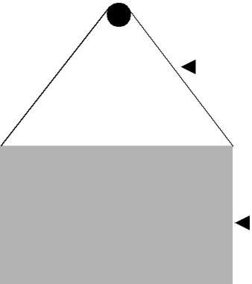

The mass of the picture is uniformly distributed and PX = PY.

Which of the following best represents the free body diagram of the forces acting on the peg?

A. B.

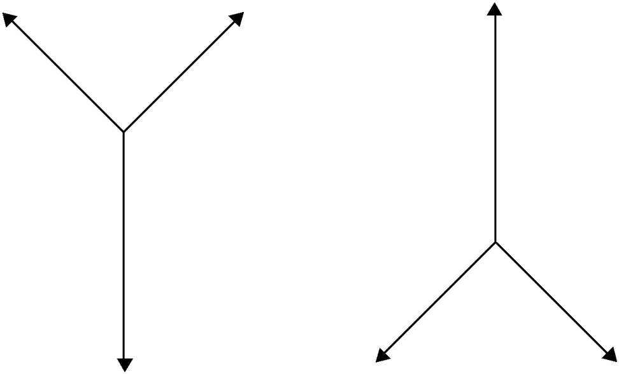

|  |  |  |
| --- | --- | --- |
| C. | D. |  |
|  |  |

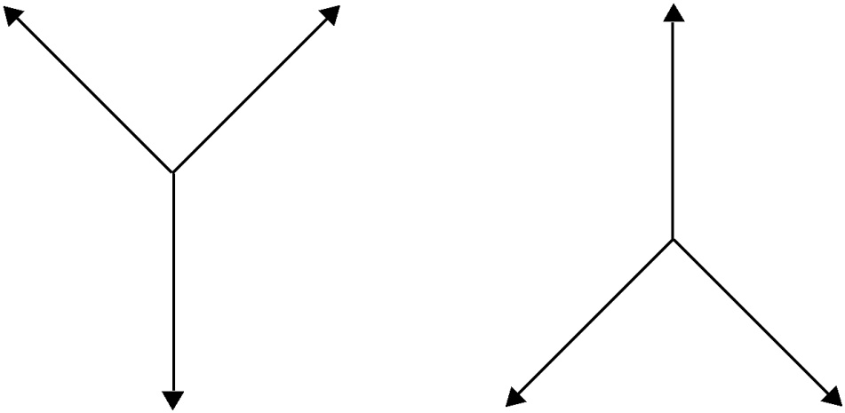

17. A block slides from rest down a smooth slope onto a rough horizontal floor where it comes

to rest.

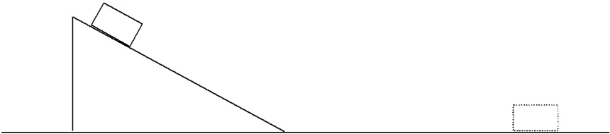

Which of the following best represents the energy changes taking place?

* 1. Potential → kinetic → potential
  2. Kinetic → potential → thermal
  3. Potential → thermal → kinetic
  4. Potential → kinetic → thermal

18. An object of weight 50 N is dragged up an inclined plane at constant speed, through a

vertical height of 12 m. The total work done is 1500 J.

The work done against friction is

* 1. 2100 J.
  2. 1500 J.
  3. 900 J.
  4. 50 J.

19. Which one of the following is a true statement about energy?

1. Energy is destroyed due to frictional forces.
2. Energy is a measure of the ability to do work.
3. More energy is available when there is a larger power.
4. Energy and power both measure the same quantity.

20. Why does the pressure of a gas increase when the gas is compressed at constant

temperature?

A. The gas molecules collide more often with each other.

B. The gas molecules expand under pressure.

C. The gas molecules hit the walls of the container more frequently.

D. The gas molecules travel faster.

**21** Two springs X and Y have spring constants *k* and *2k* respectively.  
Spring X is stretched by a force *F* and spring Y is stretched by a force 2*F*. Each spring obeys Hooke’s law during the extension.

The work done in stretching spring X is *W*X and the work done in stretching spring Y is *W*Y*.*What is the relationship between *W*X and *W*Y?

A *W*Y = *W*X

B *W*Y = *W*X

C *W*Y = 2*W*X

D *W*Y = 4*W*X

**22** The force on a sample of a material is slowly increased and then slowly decreased. The

force–extension graph is shown in the diagram.

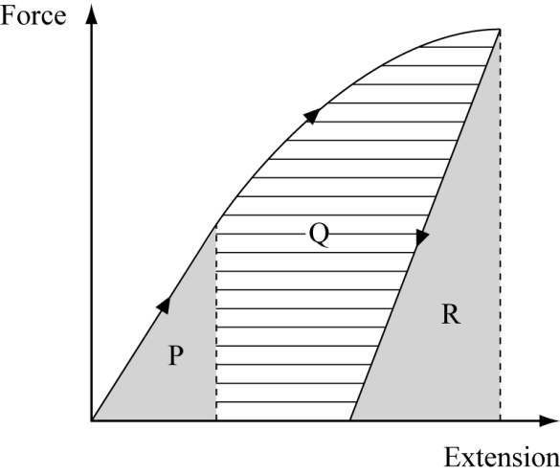

Which area represents the net work done on the sample during the complete process?

A P + Q B Q + R C P + Q – R D P + Q + R

**23** Which statement defines electric field strength between two parallel plates?

**A** Electric field strength is equal to the charge per unit distance between the plates.

**B** Electric field strength is equal to the force per unit charge.

**C** Electric field strength is equal to force times the distance between the plates.

**D** Electric field strength is equal to the potential difference times the distance   
between the plates.

**24** The diagram shows two parallel, charged plates.

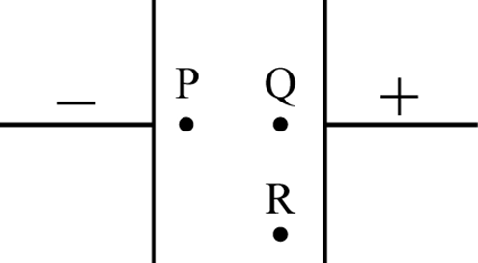

Which statement about the electric field at points P, Q and R is correct?

A The field at P is greater than the field at Q and R.

B The field at P is less than the field at Q and R.

C The fields at P and Q are equal but greater than the field at R.

D The fields at all points P, Q and R are all equal.

**25** The diagram shows part of a circuit.

What is the current X ? 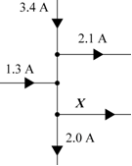

A 0.6 A

B 2.0 A

C 4.8 A

D 6.2 A

**26** The diagram shows a circuit. The current in the circuit is 0.8 A.

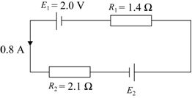

What is the e.m.f of the cell E2 ?

A 0.56 V

B 0.80 V

C 2.80 V

D 4.80 V

**27** The diagrams show two wires both made from the alloy eureka. Wire 1 has length *L*, diameter *d* and resistance *R.* Wire 2 has length 2*L* and diameter 2*d.*

**wire 1 wire 2**

What is the resistance of wire 2?

**A** *R*

**B** *R*

**C** *R*

**D** 2 *R*

**28** The graph shows the variation of the resistance of a thermistor with temperature.

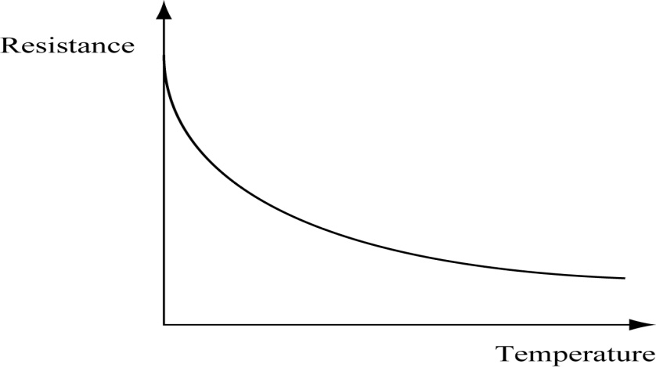

Which conclusion can be made directly from the graph?

**A** The resistance of the thermistor increases when the current through it increases.

**B** The resistance of the thermistor increases when the potential difference across it decreases.

**C** The resistance of the thermistor increases when the temperature of the thermistor decreases.

**D** The resistance of the thermistor increases when the temperature of the thermistor increases.

**29** The diagrams show a potentiometer being used to compare two resistors. The ammeter in each circuit reads zero.

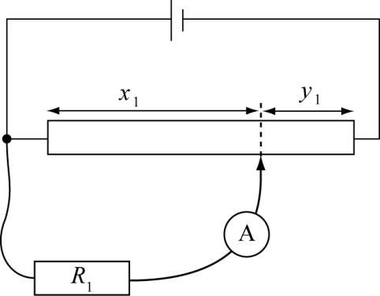 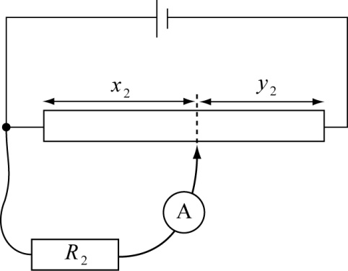

What is the ratio of the two resistances?

**A **

**B **

**C **

**D **

**30** Astudent designs a circuit to give an decreasing voltage output as the temperature increases. She builds the circuit in the diagram, but finds that the output voltage increases with increasing temperature.

output

A friend suggests four possible changes to the circuit.

Which change would produce the effect she wanted?

**A** Replace the resistor with one of higher resistance.

**B** Replace the resistor with one of lower resistance.

**C** Reverse the polarity of the battery.

**D** Swap the position of the thermistor and the resistor.

**31** Which of the following **cannot** be polarised?

**A** infrared waves

**B** microwaves

**C** sound waves

**D** ultraviolet waves

**32** The graph shows two waves.

Displacement

Time

Which statement is correct?

A The waves are coherent and in phase.

B The waves are coherent but out of phase.

C The waves are incoherent and out phase.

D The waves are incoherent but in phase.

**33** A student sets up a experiment to show interference of light.He uses two small red LEDs as the light sources.  
Which of the following explains why he will not be able to show interference?

**A** The light from anLED does not does not have a single wavelength.

**B** The light from an LED does not have a constant frequency and so will not be in phase.

**C** The light from the two LEDs will not be in phase.

**D** The light from the two LEDs will not be coherent.

**34** An experiment is set up to demonstrate interference from different types of electromagnetic radiation. The apparatus is shown below and the dimensions are kept constant for all types of radiation.

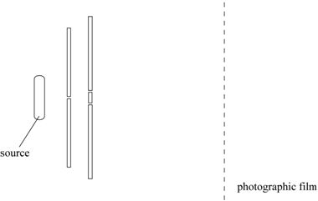

Which type of radiation will produce fringes which are the closest together?

**A** blue light

**B** infrared radiation

**C** red light

**D** ultraviolet radiation

**35** Which of the statements about stationary waves is true?

**A** A node occurs where the vibration is at a maximum.

**B** An antinode occurs where the vibration is at a maximum.

**C** The distance between consecutive antinodes is one wavelength.

**D** The distance between consecutive nodes is one wavelength.

**36** The diagram shows the apparatus used to measure the wavelength of microwaves.

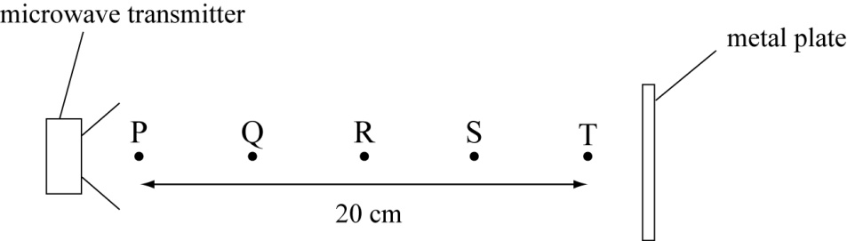

As a detector is moved from the transmitter to the metal plate, maxima are found at points  
**P**, **Q**, **R**, **S** and **T**. What is the wavelength of the microwaves?

**A** 4 cm

**B** 5 cm

**C** 10 cm

**D** 40 cm

**37** A vibrating tuning fork, held above a tube, sets up a standing wave in the air in the tube.  
Which of the following statements is correct?

**A** At the antinodes the particles vibrate back and forth, parallel to the length of the tube.

**B** At the antinodes the particles vibrate from side to side, perpendicular to the length of the

tube.

**C** At the nodes the particles vibrate back and forth, parallel to the length of the tube.

**D** At the nodes the particles vibrate from side to side, perpendicular to the length of the tube.

**38** What can be assumed to be the maximum range of an -particle in air?

**A** a few millimetres

**B** a few centimetres

**C** a few metres

**D** a few kilometres

**39** In an α-particle scattering experiment a very thin gold film is bombarded with α-particles.   
What is observed?

**A** A few α-particles are deflected through an angle greater than 90º.

**B** Most α-particles are deflected through angles greater than 90º.

**C** No α-particle continues on its original path.

**D** No α-particle is deflected through an angle greater than 90º.

**40** What can be concluded about a gold nucleus when α-particles are scattered by a thin gold foil?

**A** The nucleus contains protons.

**B** The nucleus contains neutrons.

**C** The nucleus is much smaller than the size of the atom.

**D** The nucleus is surrounded by electrons.